Project Design Phase
Solution Architecture
Date | 29 September 2026
Team ID | SWTID-2026-9791
Project Name | Streamlining IT Procurement: Automating Standard Laptop Orders with Flow Designer
Maximum Marks | 4 Marks
Team Size | 3
Team Leader | MONIKA S
Team Member | PREETHA S
Team Member | RANJANI DEVI M

Solution Architecture:
Solution architecture describes the major components and data flow that connect the IT procurement process with the automated Flow Designer technology solution. The architecture defines how a standard laptop order request is triggered, validated, approved, and fulfilled automatically.
• Provide a clear flow from user standard laptop order submission to final asset delivery.
• Use ServiceNow Flow Designer to automate approvals, task routing, and status notifications.
• Integrate with Asset Management / CMDB to verify inventory levels prior to task assignment.
• Auto-assign fulfillment tasks (imaging, hardware configuration, dispatch) to IT teams.
• Log stage progression and audit trail for SLA tracking and procurement transparency.

Solution Architecture Diagram:
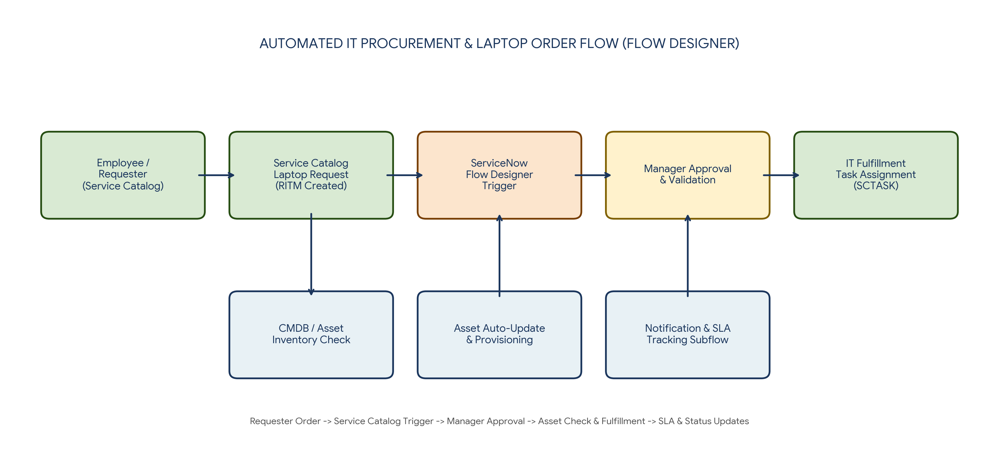
Figure 1: Architecture and data flow of the Standard Laptop Procurement Flow Designer solution
Reference:
https://aws.amazon.com/architecture/
https://www.ibm.com/cloud/architecture

